Strategies for Better Communication and Connection During this Challenging Time
Presented by Deb Early, LPC, CEAP, UVA FEAP
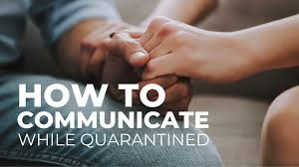

1. Take space for You and your relationship

2. use relational space for the good and not the bad

3. pause and be intentional with your relationship

4. Own it! Own your own issues coming into the relational Space

5. Acknowledge strengths, GRATITUDES AND/OR APPRECIATIONS FOR THE OTHER.

